**Progress Report #1**

**FINALS PROJECT**

Web Systems and Technologies Lecture

9331A

03:00 - 4:00 TF:

Agpaoa, Aldrin

Festejo, Leo Dominique,

Mones, Angelica,

Pagaduan, Jonabelle

Soriano, Ma. Rosmella Jhoy

**Friday, 27 April 2018**

**What the group has accomplished so far:**

The group has started drawing plans for the development of the website. We have discussed the initial design of the website and the technologies we’ll be using for the actual development. Figure 1 below shows the site architecture that we have designed based on the required topics to be featured on the website as well as the advanced technologies of our choosing. The technologies to be featured in our website are the following:

* Java Web Technologies
* PHP (Hypertext Pre-processor)
* Javascript (Node.Js)
* (ASP.net) Active Server Pages
* Web Application Security (OWASP 2017)

**What the group will plan to accomplish:**

From the website architecture and user experience design comes the actual coding phase of the project. We will start with the base of the website structure – HTML with properly designed and formatted elements for easy targeting/selection for the CSS component of the site. Next, we will insert the JavaScript code to the interactive elements of the site (buttons, tabs etc). The group will also be adding responsive web design for viewing in different devices as per web development standards.

The group will be discussing the addition of interactive content such as account creation for the visitors of the site. Plus they’ll have the option participate in an interactive game (quiz type) with the results at the end of the quiz.

The project group is planning to utilized commonly used frameworks and libraries such as Bootstrap and others.

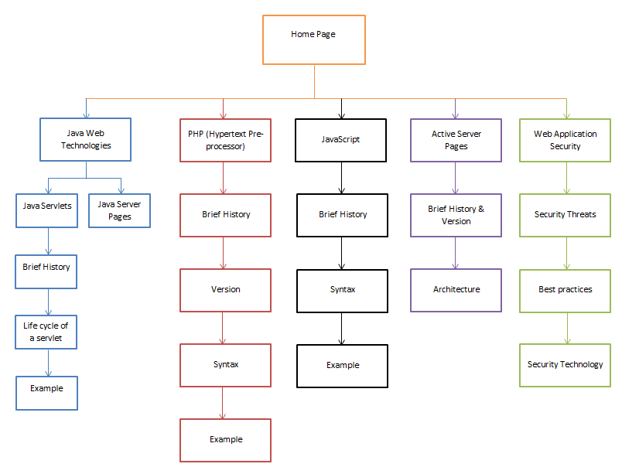

**Figure 1 – Site map / architecture**

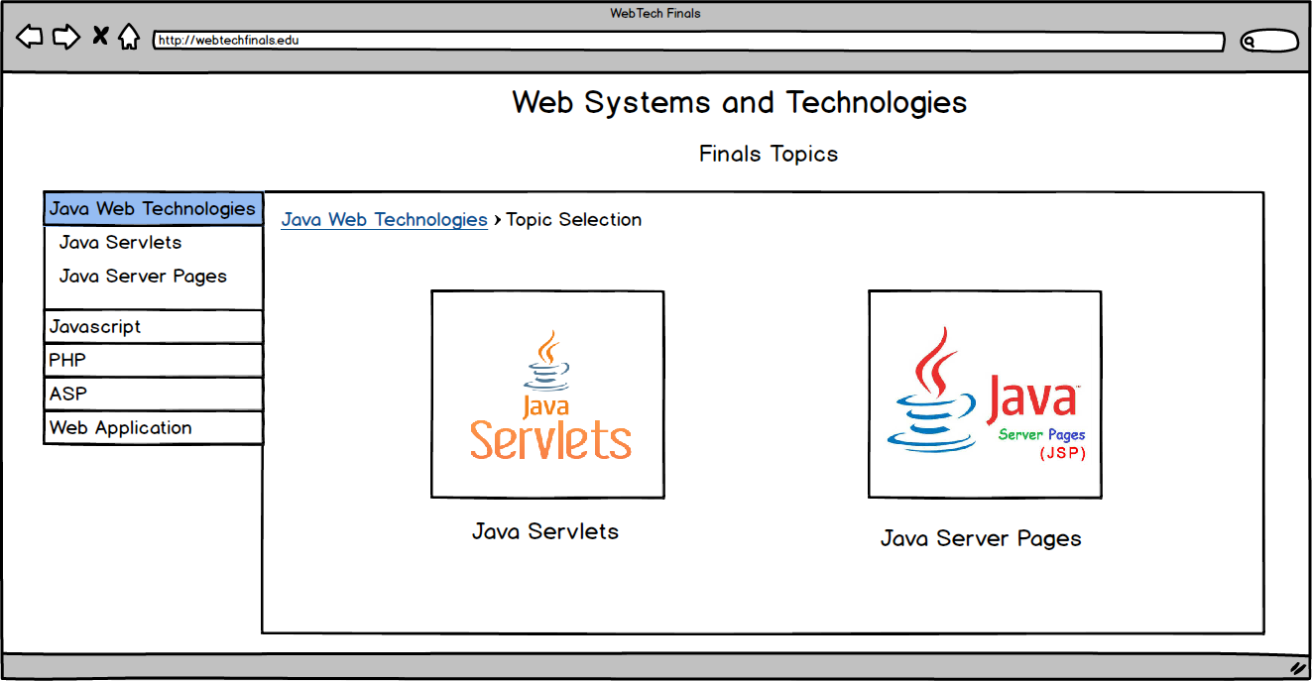

**Figure 2 – Java Web Technologies page**

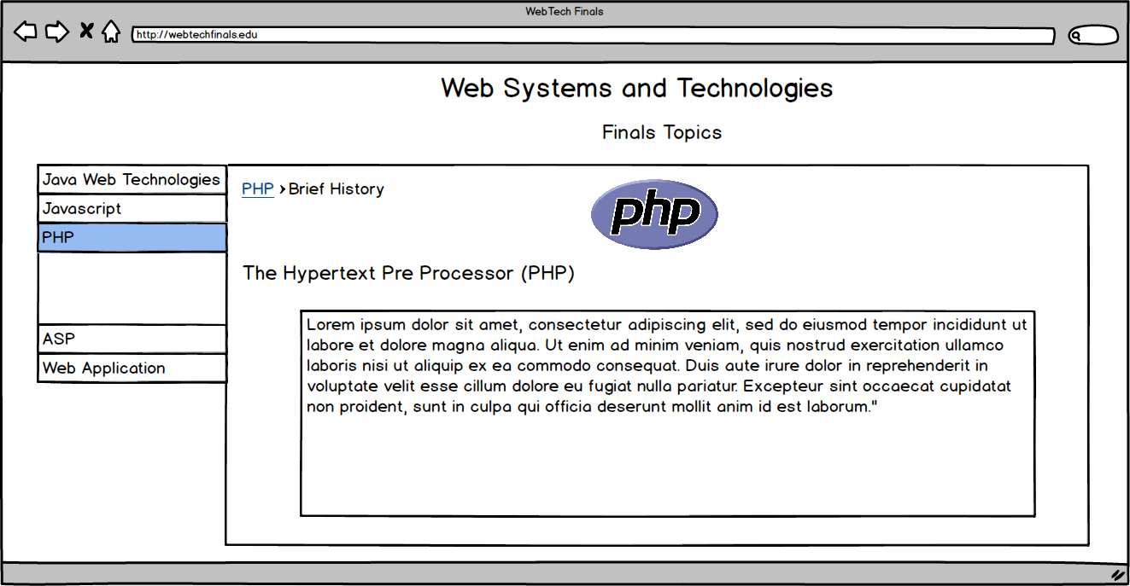

**Figure 3 – PHP page**

**Proof of Work**

Commit Logs from GitHub:

